**Day 03 API Integration**

Process:

Overview: Connecting an external API to get food-related stuff and linking it to the Sanity CMS for the project.

Steps Taken: key variable included:

* NEXT_PUBLIC_SANITY_PROJECT_ID
* NEXT_PUBLIC_SANITY_DATASET
* SANITY _TOKEN

Sanity client creation:

* Used @sanity/line to hook up the project to Sanity.
* Set up the client with the project ID, dataset, API version, and auth token to make it all work.

Data Fetching: Used axios to make API calls at the same time to get food and fetched data.

Data Processing:

* Worked through the data we fetched.
* Used the client.assets.upload method to add images to Sanity’s asset library.

Sanity Documents creation:

* Changed the fetched data into a format that works with Sanity.
* Structures. uploaded each document client.create.

**Error Handling:**

* Set up strike-through blocks for making API calls and working with Sanity.
* Logged errors to troubleshoot the issues.

**Screenshot of API calls:**

**Chefs:**

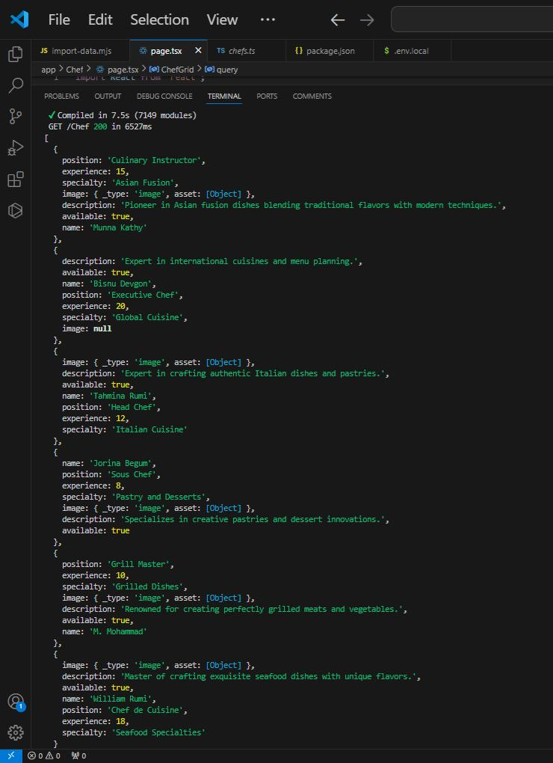**Foods:**

